1. Brief Description of the topic: This journal is on ipv6 addressing and routing.

2. Topology import:

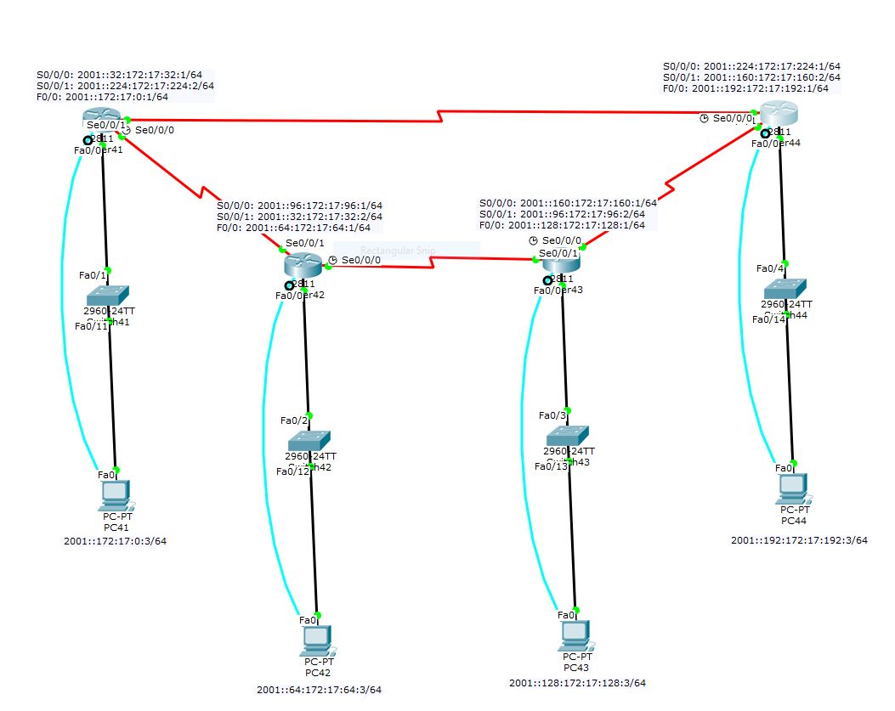

3. Table of Command Syntax and the associated description:

|  |  |
| --- | --- |
| Command | Description |
| Ipv6 unicast-routing | Enable ipv6 routing |
| Ipv6 address x:x:x::x/y | Ipv6 address x with prefix y |
| Ipv6 router ospf 1 | Enable ospfv3 |
| Ipv6 ospf 1 area 0 | Add network to ospf area |
| Ipv6 router eigrp 307 | Enable ipv6 eigrp |
| Ipv6 eigrp 307 | Add network to eigrp |

4. Verification (ie: ping, tracert, traceroute tools and output)

OSPFv3 routing tables:

Router 41:

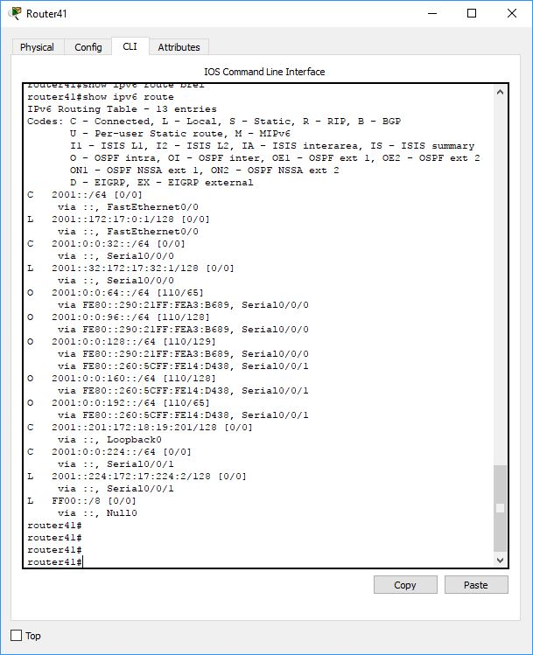

Router 42:

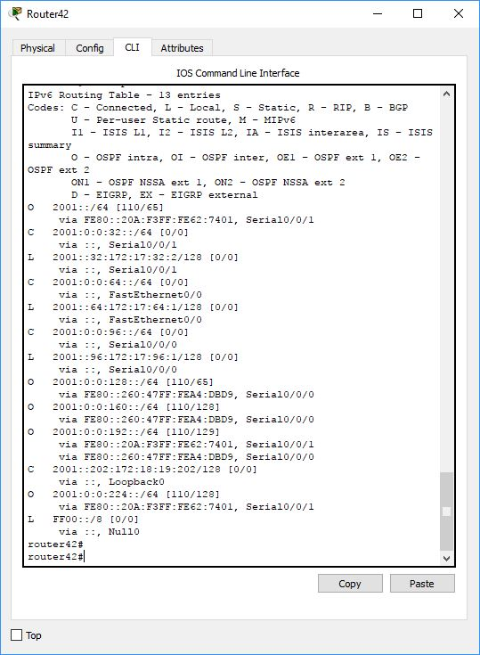

Router 43:

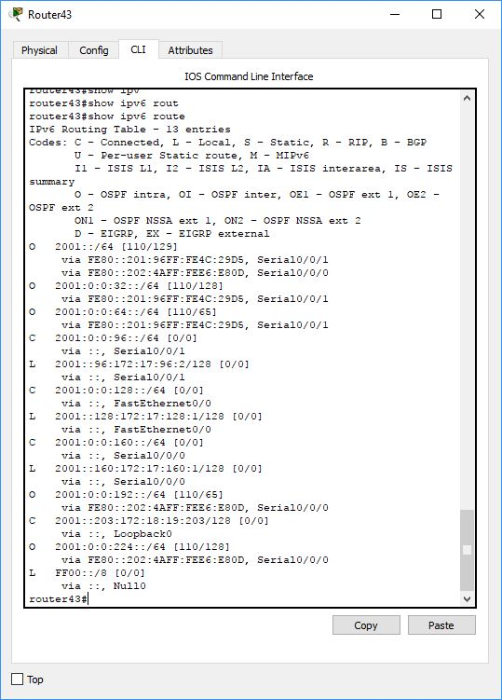

Router 44:

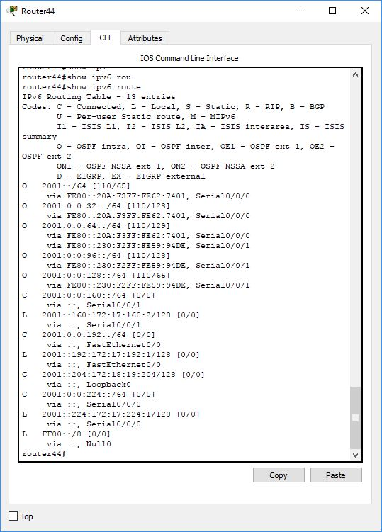

Pc4 pinging all other pc’s:

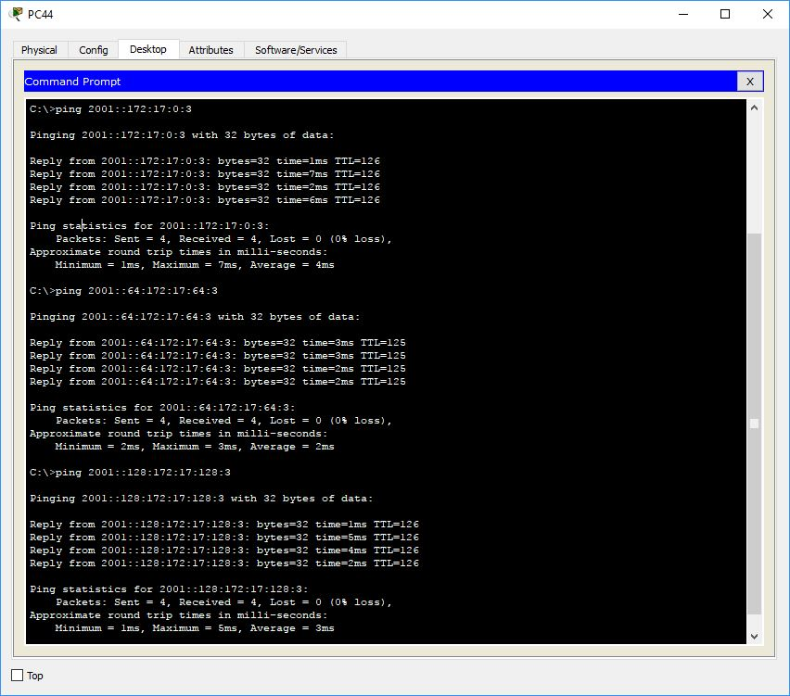

EIGRP:

Router 41:

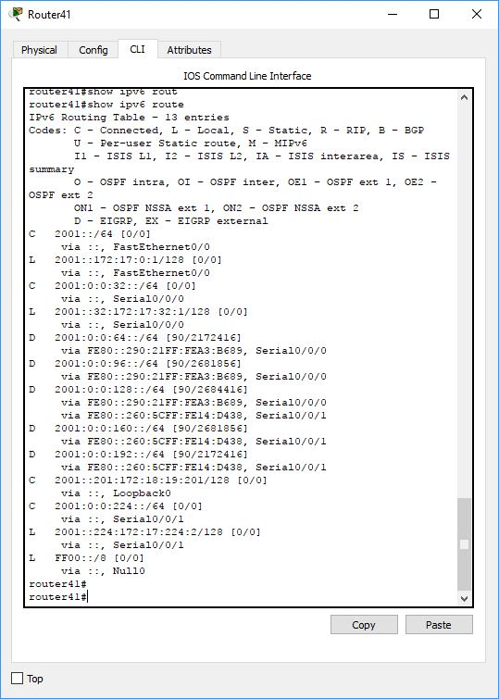

Router 42:

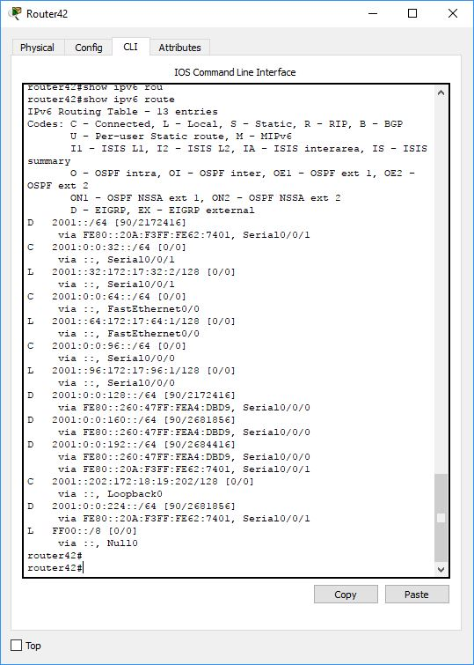

Router 43:

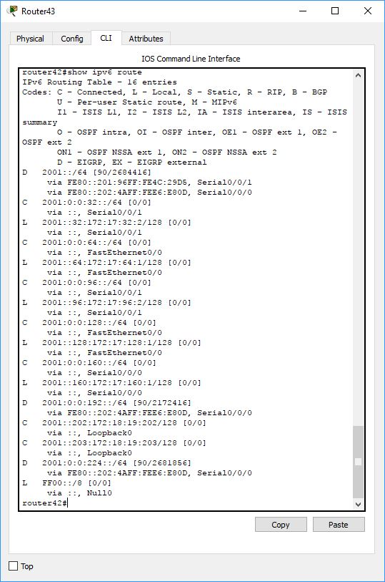

Router 44:

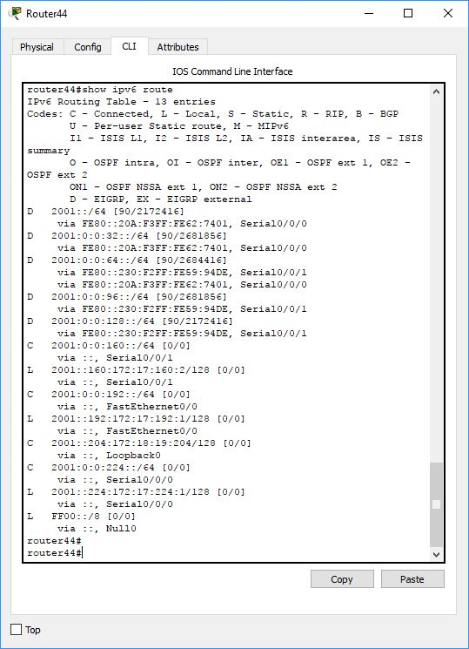

Pc 4 pinging all other pc’s:

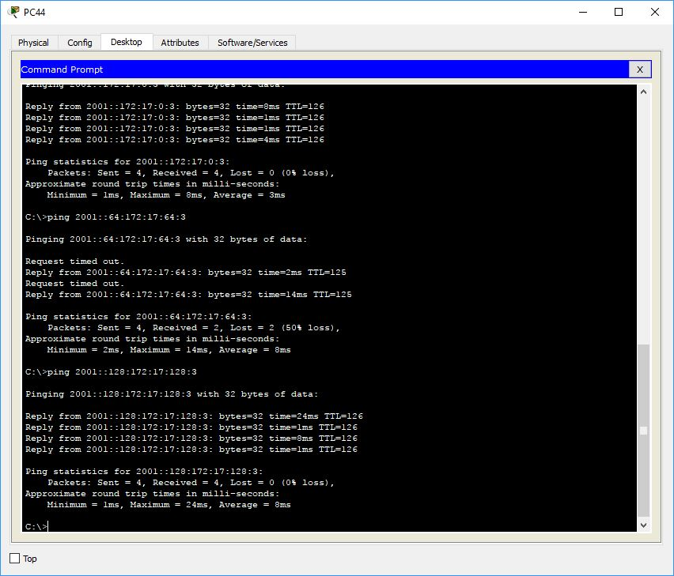

5. Results / Outcomes: Once again everything seemed to work. There was a small issue. After setting up eigrp pc42 had a hard time pinging pc43 and pc44. After using tracert I found the problem to be something about how router42 and router43 are set up. I could not find anything else. From pc43 I could ping f0/0 on router42 with no issues, it was only when I tried to ping pc42 that it didn’t work.